SIMS – SOS Information Management System
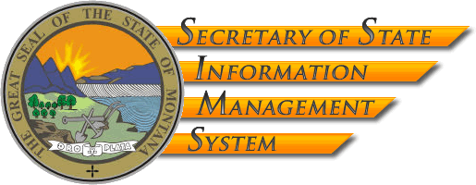
Change Management Plan

July 2009

Revision History

Revision | Date of Release | Purpose
Initial Draft | March 17, 2008 | Initial Release
Update | January 7, 2009 | Update with known RFP, proposal, and contract information.
Update | June 30, 2009 | Update with known RFP, proposal, and contract information
Update | July 16,2009 | Update with Mike Homsher comments and clarify language. Change RightNow to SharePoint
Update | July 21,2009 | Additional changes from Mike Homsher and other typographical and formatting edits

Table of Contents:

I. Plan Goals and Objectives: 3
Standard Issues 3
Defect Notification 4
Decision Requests 6
Change Requests 8
Workflows for Change Management 10

General Information:

I. Plan Goals and Objectives:

The objectives and goals of this Change Control Plan for the SIMS Project are to define how standard issues, decision requests, defects and changes will be documented as Investigation Reports and how they will be handled throughout the life of the project.

The SIMS Project will be using a help desk system provided via SharePoint hosted in the SOS environment. The Investigation Report (IR) List will be the primary repository for all project requests relating to the system. The IR list will include an electronic form that will allow individuals to enter a ticket that includes the details of the IR. This includes all phases of system development–from requirements, through development, test, acceptance test and deployment.

This application is very customizable and has extensive reporting capabilities. Contractor will be granted ‘contributor’ access to the application, which will allow for the entry, manipulation and resolution of Investigation Reports and includes the ability to generate reports by selecting different views of the data.

At the highest level, people initiate this change process when they encounter a situation that they cannot solve by reasonable effort such as checking documentation, discussion with team members, or other informal problem solving. This may be hardware, software, application, business process or testing related. At the point the person discovers that they cannot resolve the situation, the will enter an Investigation Report. This IR ticket is used to record the situation and request assistance from the project team for resolution.

Investigation Report (IR) – All issues, decision requests, and changes that cannot be resolved through reasonable efforts will first be documented as an Investigation Report ticket using an eForm in the SharePoint list for the SIMS project. The IR eForm will contain fields to log such information as:
- IR title
- Description,
- Type of IR (defect, user training, question, change request, etc.), who entered the ticket,
- Entry date, time and person
- Action taken on the ticket
- Person assigned to work the ticket
- Person accepting the ticket as completed
- Change request information (time, schedule, cost)
- Release Information (details on roll into code set)
- Other items as needed by the team

The project team member (Initiator) documenting the issue will adequately describe the issue (including representative screen prints, if applicable) and upon saving the item, the system will send an alert to the assigned Change Lead (CL). The CL is the front line of the Investigation Report team. They will triage each ticket and will determine:
  - If the ticket is a defect and needs to be routed to a team member or Project Manager (PM) for resolution.
    - A help guide will be created to assist the CL in determining the type of defect and proper deposition.
  - If the ticket should become a formal decision request or change request. IRs that are determined to be a decision request or a change request will be documented and elevated through the formal processes as described below.
  - If the IR can be handled informally—if so, the CL will decide which team member or PM (SOS, contractor, or both) needs to review the issue, and will route the IR for resolution.

Tickets can be moved between these types (defect, decision, change, etc.) as needed by the team.

The resolution information will be documented in the ticket eForm, along with any attached documentation needed for clarification. All decision information will be summarized in the ticket online. The CL has the initial triage authority, but PMs on both teams will be alerted of changes and can work with the CL if a ticket is heading down a path that may need to be altered.

The assigned PM (SOS or Contractor) will be responsible for updating any project deliverables, the project schedule, and/or other project control documents, if required by the finalized IR resolution.

Defect Notification- When a ticket is determined to be a Defect, the Contractor PM will review the defect and its supporting documentation and determine whether the issue is truly a defect or a Change Request. A defect is defined as existing functionality that when executed produces an error resulting in inaccurate or unexpected results. If it is confirmed as a Defect, then the Contractor PM will determine its category (data, conversion, application, documentation, configuration, etc.) and its urgency (low, medium, high, critical) and notify the SOS PM for concurrence. The defect will then be routed to the appropriate resource for resolution. The involved team members will continue to use the online ticket to record. This includes details on the defect, resolution, test information and migration information.

Application defect resolutions undergo the following steps at a minimum:
- Unit test by the Developer
- Functional test by the Implementation Team
- Acceptance test (signed) by the Initiator.
Configuration, Conversion, and Documentation defect resolutions undergo the following steps at a minimum:
- Unit and Functional test by the Implementation Team
- Acceptance test (signed) by the Initiator.
The status is then updated in the online system.

Any tickets of high priority that cannot be resolved within timeframes per the contract (or a reasonable time for any situation not defined in the contract) may indicate additional issues. The SOS PM will evaluate these items and will elevate them through the decision and then CCB process for resolution as needed.

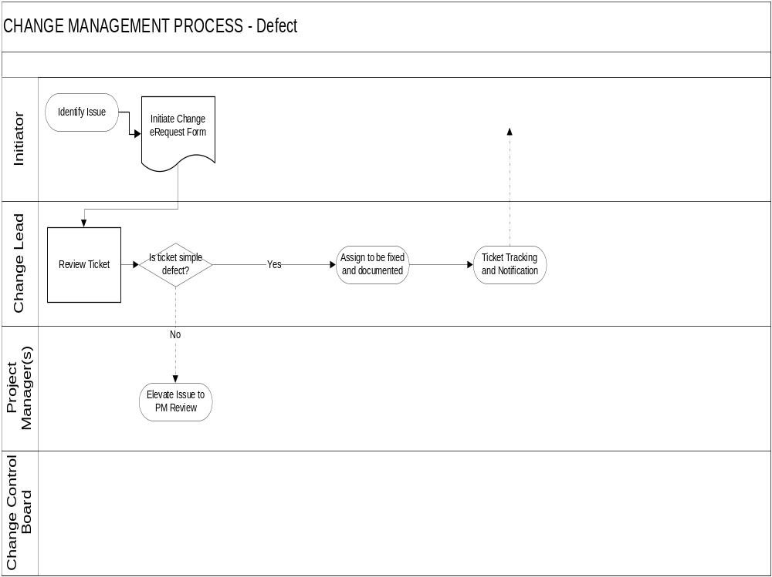

Decision Requests – When a ticket is elevated to a decision request, the PMs (both SOS and Contractor) will review the ticket and determine the correct course of action required to fully evaluate and analyze the IR. Together, the PMs will decide which PM will be assigned the ticket. That PM will gather the appropriate information, resources, and data required to address the IR. They will then route the ticket as appropriate for resolution.

Decision Requests will be fully documented in the IR list online. The IR list will allow additional documentation to be attached to the ticket, and the action log provides a location for decision makers to document their decision.

The PM assigned to work the ticket will be responsible for updating any project deliverables, the project schedule, and/or other project control documents, if required by the finalized decision request.

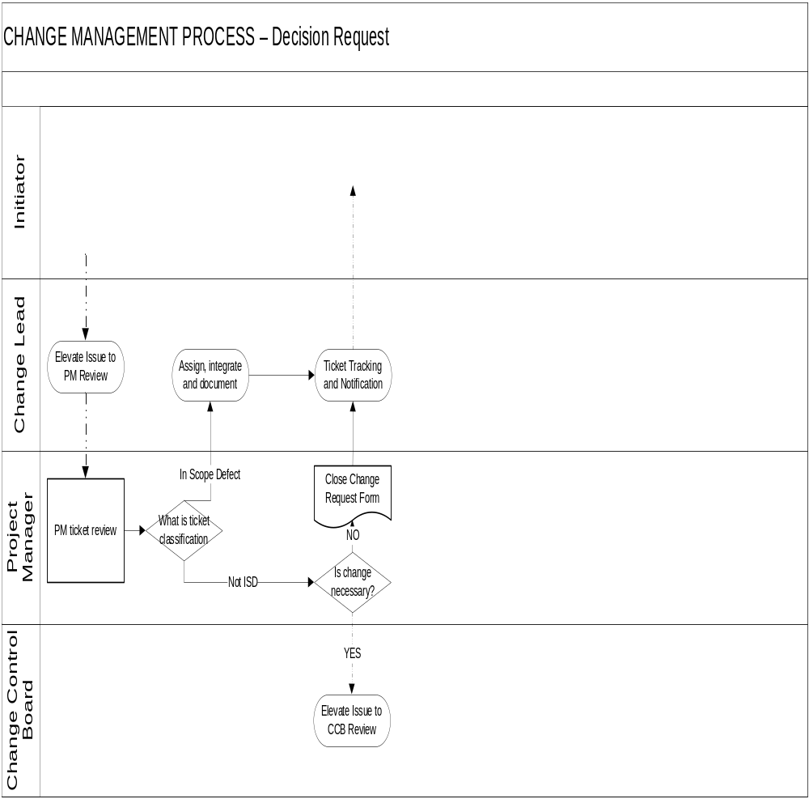

Change Requests - When a ticket elevated to Change Request level, the PMs (both SOS and Contractor) will review the Change Request and determine the correct level of authority required to approve the request. They will then route the ticket as appropriate for resolution. If the Change Request does not require a review by the CCB, the SOS PM will work through a CCB ‘lite’ process (subset of the CCB, or full CCB via email). The people involved in the CCB ‘lite’ process will be determined by the PMs and will be appropriate for the subject matter contained in the IR. If the CCB ‘lite’ is able to process the ticket, the appropriate steps for resolution and closure (including all documentation of the process) will be taken. If, however, a full analysis is needed, it will be routed to the Change Control Board for review and approval/denial. The impact of the change request will be documented on the eForm in the online ticket, for Change Control Board review.

The Change Control Board will analyze the request, asking for additional information from the PM assigned to the ticket if needed. The CCB will provide a decision to the PM assigned to the ticket, who will route the ticket along the correct work path. The ticket will then flow to the appropriate steps for implementation (if approved) resolution and closure (including all documentation of the process).

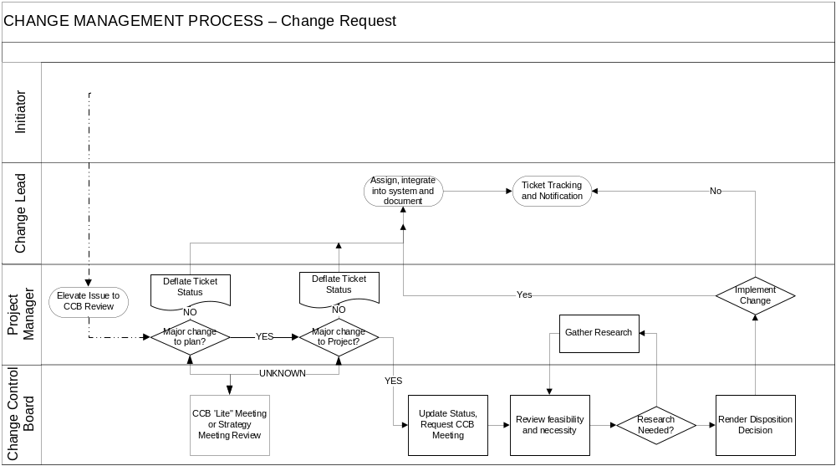
If the ticket will be implemented, the PM leading the team responsible for the work (SOS or Contractor) will create a Task Order and will assign approved Change Requests to the appropriate resource, who will create a Functional Specification (spec) for signature approval by the other team Project Manager. The spec will include an estimated completion date that the assigned PM will add to the Project Plan.

Application defect resolutions undergo the following steps at a minimum:
- Unit test by the Developer
- Functional test by the Implementation Team
- Acceptance test (signed) by the Initiator.
Configuration, Conversion, and Documentation defect resolutions undergo the following steps at a minimum:
- Unit and Functional test by the Implementation Team
- Acceptance test (signed) by the Initiator.
The status is then updated in the online system.

Section 4.2.2 provides the contractual terms for Change Requests that are approved through a Task Order. This information will not be repeated here in full, but the following characteristics are worth noting:
- Each Task Order will contain the specifications, acceptance criteria and testing to be performed.
- Each Task Order will contain a schedule for the expected design, development, implementation and integration.
- Task Order’s which exceeds for four hours for review and sizing will generate and estimate for completion from the Contractor.
- Each Task Order will provide detail on impacts to the project plan, delivery schedule, and SOW deliverables.
- Payment provisions (positive or negative) and schedule will be included in the Task Order.

Workflows for Change Management
*note – in most instances the act of ‘forwarding’ or ‘routing’ will be performed systematically using workflow rules in the SharePoint online list.
Issue/  Decision Request | Defect | Change Request
Initiator - The Person that writes up the initial issue or decision request, and routes it to the SOS PM and Contractor PM for review. | Initiator - The Person that discovers and documents the system defect experienced, and routes it for Project Management Review. | Initiator – Any person that would request a change be made to the project requirements. After documenting the requested change, they would forward the request to the Project Management team.
Project Management Review - The SOS PM and Contractor PM will review the issue statement or decision request and determine the correct level of authority required to address the issue. They will then route the Issue/Decision Request as appropriate for resolution. | Project Management Review - The review of the documented defect by the SOS PM and Contractor PM to determine if there is truly a system defect. | Project Management Review - The review of the requested change by the SOS PM and the Contractor PM to determine if the change request needs to be elevated to the Change Control Board or will be resolved by Project Management.
Steering Committee - Issues or Decision Requests will be reviewed by the steering Committee when requested by either PM. Their analysis will be documented and the SOS PM will work with the Contractor PM to take the next appropriate course of action | Assigner - The PM who will assign the defect to one of the team members for integration. | Change Control Board - Will be made up of the following roles:  - Secretary of State  - Chief of Staff  - Deputy Chief of Staff  - SOS Project Manager  - FileONE President  - Director of Product Development  - FileONE Project Manager  They will review the impact, assess the value of the requested change, and determine whether to implement the change.
Assigner - The PM who will assign the decision to one of the team members for integration. |  | Assigner - The PM who will assign the approved change to one of the team members for integration.
Implementation Team - The project team that will ensure requirements, testing and artifacts are appropriately updated. | Implementation Team - The project team that will ensure requirements, testing and artifacts are appropriately updated. | Implementation Team - The project team that will ensure requirements, testing and artifacts are appropriately updated.
Initiator - The Person that writes up the initial issue or decision request, final review to ensure resolution has adequately addressed the issue or decision requested. | Initiator - The Person that discovers and documents the system defect experienced, retest of scenario that discovered the defect to ensure the reported defect was fixed. | Initiator – Any SOS staff or manager that would request a change be made to the project requirements. After the requested and approved change has been implemented, the initiator would review to ensure the change was properly implemented.

EXECUTION

The parties through their authorized agents have executed this contract on the dates set out below.

SECRETARY OF STATE’S OFFICE | FileONE, INC.
PO BOX 202801 | 5520 DILLARD DRIVE, SUITE 280
HELENA MT 59620-2801 | CARY NC 27518
 | FEDERAL ID # 56-2137429
BY: | BY:
(Name/Title) | (Name/Title)
(Signature) | (Signature)
DATE: | DATE:
Approved as to Legal Content:
Legal Counsel (Date)
Approved as to Form:
Procurement Officer (Date)
State Procurement Bureau

Chief Information Officer Approval:

The Contractor is notified that pursuant to section 2-17-514, MCA, the Department of Administration retains the right to cancel or modify any contract, project, or activity that is not in compliance with the Agency's Plan for Information Technology, the State Strategic Plan for Information Technology, or any statewide IT policy or standard.

Chief Information Officer (Date)
Department of Administration

